Meta Title:
Get professional beauty school services at Image Academy
Meta Description:
Looking for Beauty School Services in Houston, TX? All you need including Blow Out, Hair Cut, Hair Color, and Facials will be met at Image Academy.
Services Page
https://imageacademy.org/service/
beauty school services | 140 | 8
Blow Out | 27100 | 77
HAIR CUT | 74000 | 49
Hair COLOR | 33100 | 50
FACIALS | 33100 | 48

Beauty School Services
Welcome to Image Academy, the leading Beauty Training School in Houston, TX. Our team of professional trainers offers comprehensive beauty school services such as Hair Cut, Hair Colors, Facials and Blow Out to meet diverse requirements. Here, we will bring out the best in your personality and make you shine with joy.

Blow Out
Experience the best hair transformation with expert Blow Out service from our professional staff. Display your hair brighter and shiner with great care and utmost dedication. Our hair stylist experts will make you feel more confident and stylish than ever before by creating the perfect blowout style for you. Now you can make it even better!
Book Your Blow Out Today
HAIR CUT
Get the look you want with our professional hair cutting services. Our hair stylist understands very well minute details about face features and offers customized hair cuts from modern to traditional. Get the best treatment for your hair through personalized services and quality outcomes to create a new confident image. To get your dream hair transformation, please contact us today!
Schedule Your Haircut Now
COLOR
Ready to upgrade your color style with natural shades and unique spirited hues? Get our hair coloring services from the professional experts of the Image Academy for a new look that complements your unique personality and improves overall beauty. Book your appointment to get an elegant transformation that will impress everyone!
Transform Your Look
FACIALS
Get glowing, healthy and more beautiful skin with our Facials services. For each skin concern, from hydration to anti-aging, our highly skilled professionals offer personalized treatments. Enjoy a relaxing holiday and enjoy a bright personality. And celebrate your skin’s natural beauty with a facial appointment!
Book a Facial Today

LASH TECH
Get your natural beauty fixed with our skilled lash tech services and unique lash extensions. Our lash stylists offer the best looks, perfect for completing your style and delivering beautiful, long-lasting results. Give yourself pretty elongated lashes today and experience a better look than never before.
Get Gorgeous Lashes
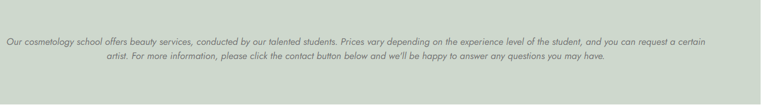

All the beauty services offered at our cosmetology school in Houston are conducted by our highly talented and professional staff. You can request certain artist services, but prices vary based on experience level. If you have any questions, please click the contact button below, and we will be happy to assist you.
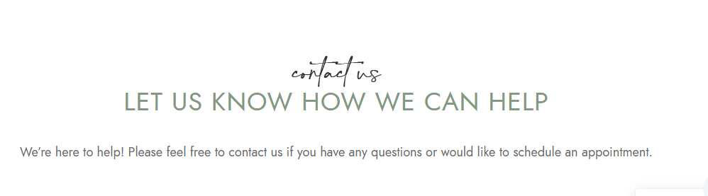
Contact Us
LET US KNOW HOW WE CAN HELP
We’re here to help! We would love to hear from you if you have any questions or would like to schedule an appointment.

Contact us

